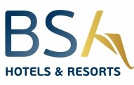
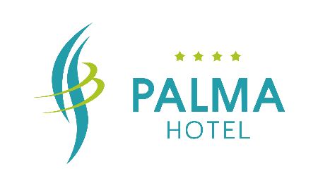
General information

The 4-star hotel “Palma” is located in a green and quit area, in the very center of Golden Sands, only 300 meters away from the beach, offering its guests excellent conditions for a comfortable vacation.
From 2023 the hotel is part of BSA Hotels & Resorts
• All-Inclusive base • Main restaurant • Lobby Bar • Pool Bar • Free Wi-Fi access on the territory of the hotel and in the rooms
• Parking • Taxi and Rent-a-car service
• Beach – 300 m away • 18km away from Varna • Varna Airport – 30 km away
• We speak: Bulgarian. English, German and Russian • 24-hour reception service and 24-hour security
Paid services
• Parking – 15BGN/day • Safe ( at The Reception) • Imported drinks and packaged foods at the Lobby Bar • Late Check-Out – if possible, with prior request

Sport and entertainment
• 2 outdoor swimming pools • Gym • Multifunctional sports hall • Table tennis • Outdoor sports ground • Daily and evening animation – six days per week • Board games

For children
• Swimming pool with children section and water slide • Outdoor mini club next to the pool • Outdoor playground • Children animation and mini disco • High chairs for babies (in the restaurant )

◊ Check – in time: from 14:00h ◊ Check-out time: until 12:00h

• Cozy and spacious rooms • Daily cleaning • Central air conditioning • Hair-dryer • Telephone • Electric kettle • Refrigerator • TV SAT in each room • Free Wi-Fi access

Accommodation
- Economy room – capacity 2+0 30m²
- Double standard room – capacity 2/2+1/3+0 30m²
- Studio – capacity 2/2+1/2+2/3+1/4 35-45m2
- One – bedroom apartment – capacity 3/3+1/3+2/3+3/4+1/4+2/5+1/6 70m²
- Two – bedroom apartment – capacity 4/4+1/ 4+2/ 4+3/ 5+1/5+2/6/6+1/7 85m²
Early check – in and late check – out are subject to hotel occupancy and at an additional cost!

All – Inclusive accommodation
Main Restaurant
Buffet breakfast* from 7:30h until 10:00h
Buffet lunch* from 12:30h until 14:30h
Buffet dinner* from 18:30h until 21:00h
*local soft drinks, tea and coffee, draft wine and beer are available the main meals

Afternoon snacks from 16:00 until 17:00 Main Restaurant
Bars
Lobby Bar from 8:00h until 00:00h
*All-inclusive drinks are available from 10:00h until 22:00h
The menu with All-Inclusive non-alcoholic drinks includes: Bulgarian soft drinks, table and sparkling water, cocktails, coffee and tea.
The menu with All-Inclusive alcoholic drinks includes: draft beer, Bulgarian alcoholic drinks, cocktails with Bulgarian alcohol, draft wine.

Pool Bar
The menu with All-Inclusive alcoholic and non-alcoholic drinks includes: coffee, tea, juice from cold ring, Bulgarian draft alcohol and soft drinks.

Other
Pets are not allowed
If necessary, the hotel reserves the right to change the described information!
According to Bulgarian legislation, smoking is not allowed in the closed parts of the hotel - lobby, restaurant, bars and restaurants.
The hotel is not responsible for lost, damaged or stolen personal belongings left unlocked and outside the safe, for the use of which an additional fee is charged.
If hotel property is broken or damaged, a fine is payable, which is imposed by the Management and paid at the reception!
In case of early departure, the hotel deducts 100% of the pre-agreed amount of the reservation and the amount for the prepaid nights is not refunded.
The taking out of food and drinks from the catering establishments is not allowed, according to the state requirements.

